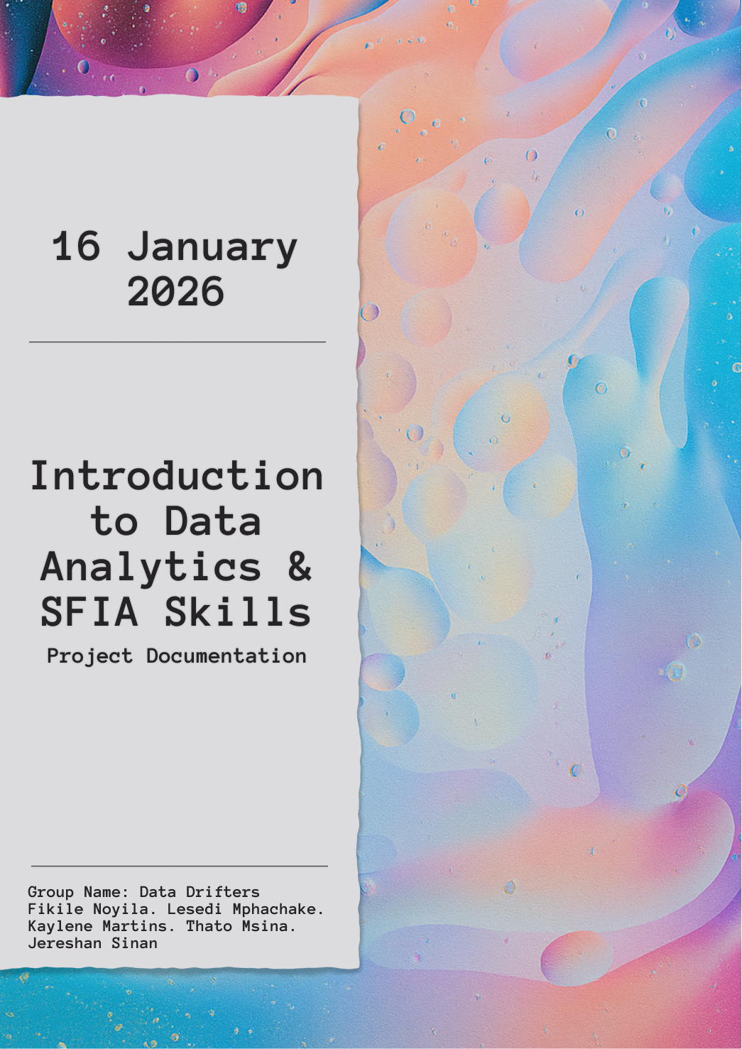

Contents

1. DATA ANALYTICS & SFIA FRAMEWORK 2

1.1 What is Data Analytics? 2

1.2 The SFIA Framework (Skills for Analysts & Engineers) 3

1.2.1 For Analysts (e.g., Data Analyst, Data Scientist) 3

1.2.2 For Engineers (e.g., Data Engineer, Software Engineer) 3

1.3 Overview of Industry Tools 4

1.4 How Are SFIA Skills Applied in Real-World Data Analytics Jobs 4

1.4.1 Data Analyst Role (e.g., in E-Commerce like Amazon or Shopify) 4

1.4.2 Data Scientist Role (e.g., in Healthcare like Pfizer or Kaiser Permanente) 4

1.5 Real-World Job Mapping 5

Job 1: Data Analyst( Full Job Description) 5

Job 2: Data Scientist (Full Job Description ) 5

CONCLUSION 6

# 1. DATA ANALYTICS & SFIA FRAMEWORK

This document provides a structured analysis of the data analytics landscape, outlining the progression from descriptive to prescriptive analytics and reviewing essential technical tools including Java, Python, Excel, and Power BI. A primary focus of this report is the application of the Skills for the Information Age (SFIA) framework, specifically examining how competencies such as Data Analytics (DAAN), Data Engineering (DENG), Data Visualisation (VISL), and Data Management (DATM) define professional roles. The document concludes by bridging theory with practice, presenting an analysis of two real-world job descriptions to demonstrate how these SFIA skills are prioritized and applied in current industry requirements.

## 1.1 What is Data Analytics?

Data Analytics is the multidisciplinary science of inspecting, cleaning, transforming, and modelling raw data to discover useful information, inform conclusions, and support strategic decision-making. In a professional environment, it is categorized into four specific types:

**1. Descriptive Analytics (What happened?)**

* **Description**: This is the most basic form of analytics. It uses historical data to describe the current state of a business. It looks at past performance and presents it in a way that is easy to understand.
* **Methodology:** Data aggregation and data mining.

**2. Diagnostic Analytics (Why did it happen?)**

* **Description**: This type of analytics takes the findings from descriptive analytics and drills down to find the root cause. It looks for correlations and anomalies to explain specific outcomes.
* **Methodology:** Drill-down, data discovery, and correlations.

**3. Predictive Analytics (What might happen?)**

* **Description**: Predictive analytics uses statistical models and machine learning techniques to identify the likelihood of future outcomes based on historical trends.
* **Methodology:** Machine Learning, forecasting, and pattern matching.

**4. Prescriptive Analytics (What should we do?)**

* **Description**: This is the most advanced stage. It doesn't just predict what will happen; it suggests specific courses of action to take advantage of those predictions or to prevent a problem.
* **Methodology:** Optimization algorithms and business rules.

## 1.2 The SFIA Framework (Skills for Analysts & Engineers)

The SFIA Framework (Skills Framework for the Information Age) is a globally recognized, vendor-neutral competency framework for describing the professional skills, competencies, and levels of responsibility required in the digital, data, technology, and ICT (information and communications technology) domains. Maintained by the not-for-profit SFIA Foundation, it has been in use for over 20 years and is adopted worldwide by governments, corporations, educational institutions, professional bodies, and individuals across nearly 200 countries.

### 1.2.1 For Analysts (e.g., Data Analyst, Data Scientist)

Analysts primarily focus on turning data into actionable insights, reporting, modelling, and decision support. SFIA covers this through skills such as:

**DAAN: Data Analytics**

* Extracting meaning from data. This involves the use of statistical and mathematical techniques to identify patterns and trends. It is the primary skill for anyone tasked with "answering questions" with data.

**Business Intelligence**

* Designing and delivering reporting/analytics solutions.

**Data Science**

* Applying advanced techniques like machine learning, statistical modelling, and predictive analytics.

**VISL: Data Visualisation**

* The art of presenting data graphically. It involves choosing the right charts, colours, and layouts to communicate complex insights to non-technical stakeholders so they can make quick decisions.

**Typical analyst roles draw from Levels 3–6:**

* Junior analysts -> Levels 3-4 (performing analyses under guidance).
* Senior/principal analysts or data scientists -> Levels 5-6 (leading projects, influencing strategy, or setting standards).

### 1.2.2 For Engineers (e.g., Data Engineer, Software Engineer)

Engineers focus on building, maintaining, and scaling systems, pipelines, infrastructure, and platforms. SFIA defines these through skills such as:

**DENG: Data Engineering**

The building and maintenance of data structures and pipelines. Data Engineers ensure that data is collected from its source, transformed, and stored in a way that is accessible and reliable for the analysts.

**DATM: Data Management**

The governance and protection of data. This includes ensuring data quality, privacy (compliance with laws like POPIA or GDPR), and creating the "Master Data" standards for an organization.

**Typical engineering roles draw from Levels 3–6:**

Junior engineers -> Levels 3-4 (building components, following designs).

Senior/lead engineers -> Levels 5-6 (architecting solutions, leading teams, ensuring scalability and governance).

## 1.3 Overview of Industry Tools

* **Java:** A high-performance, object-oriented language. In the data world, it is used primarily by **Data Engineers (DENG)** to build large-scale data infrastructures and frameworks like Apache Spark or Hadoop.
* **Python:** The most popular language for data. It is used by **Analysts (DAAN)** for statistical modelling and by **Engineers (DENG)** for automating data pipelines. Libraries like Pandas and Scikit-learn make it highly versatile.
* **Excel:** A foundational tool for **Descriptive Analytics**. It is used for quick calculations, pivot tables, and small-scale data organization.
* **Power BI:** A powerful Business Intelligence tool focused on **Visualisation (VISL)**. It connects to various data sources to create interactive, real-time dashboards for executives.

## 1.4 How Are SFIA Skills Applied in Real-World Data Analytics Jobs

SFIA skills are interconnected and often used together in data analytics workflows: from ingesting raw data (DENG and DATM) to analysing it (DAAN) and presenting findings (VISL). Here's how they apply in specific job contexts, with examples from common roles.

### 1.4.1 Data Analyst Role (e.g., in E-Commerce like Amazon or Shopify)

* **DAAN Application**: Analysts use DAAN to query sales data, identify trends (e.g., customer churn patterns), and recommend optimizations like targeted promotions. For instance, analysing user behaviour data to predict peak shopping times, leading to inventory adjustments that boost revenue by 10-15%.
* **DENG Application**: Building ETL pipelines to aggregate data from multiple sources (e.g., website logs and CRM systems) ensures clean, real-time data feeds for analysis, preventing delays in reporting.
* **VISL Application**: Creating dashboards in Tableau to visualize key metrics like conversion rates, enabling non-technical stakeholders (e.g., marketing teams) to quickly grasp insights and make data-driven decisions.
* **DATM Application**: Enforcing data quality policies, such as validating customer data for accuracy, to comply with privacy laws and maintain trustworthy datasets for analysis.

### 1.4.2 Data Scientist Role (e.g., in Healthcare like Pfizer or Kaiser Permanente)

* **DAAN Application**: Applying statistical models to patient data for predictive analytics, such as forecasting disease outbreaks or treatment outcomes, which informs resource allocation and improves patient care efficiency.
* **DENG Application**: Designing secure data pipelines to handle sensitive health records from electronic health systems, integrating them with AI models while ensuring scalability for large datasets.
* **VISL Application**: Developing interactive visualizations (e.g., in Power BI) to map epidemic spreads, helping policymakers understand geographic risks and prioritize interventions.
* **DATM Application**: Implementing governance frameworks to manage data ethics and compliance (e.g., anonymizing patient info under HIPAA), optimizing data assets for long-term research value.

## 1.5 Real-World Job Mapping

Below is the mapping of requirements tailored towards 2 job descriptions to the SFIA framework:

### Job 1: Data Analyst( [Full Job Description]((https:/www.pnet.co.za/jobs--Data-Analyst-Johannesburg-North-Network-Contracting-Solutions--4118235-inline.html?utm_campaign=google_jobs_apply&utm_source=google_jobs_apply&utm_medium=organic))

|  |  |  |  |
| --- | --- | --- | --- |
| **Job Requirement** | **SFIA Skill Code** | **Assigned Level** | **Justification** |
| "Identify trends, patterns, and insights to support strategic initiatives." | **DAAN** | **Level 3 (Apply)** | The candidate must independently apply analytical tools to find business trends. |
| "Develop and maintain dashboards and reports (Power BI/Tableau)." | **VISL** | **Level 3 (Apply)** | Requires the selection and application of visualization techniques for stakeholders. |
| "Experience with ETL processes and data integration tools." | **DENG** | **Level 3 (Apply)** | The analyst is expected to perform "engineering Lite" tasks to move and clean data. |
| "Perform data validation and ensure accuracy and integrity." | **DATM** | **Level 3 (Apply)** | The candidate is responsible for the quality and reliability of the data they use. |

### Job 2: Data Scientist ([Full Job Description](https://vodafone.eightfold.ai/careers/job/563018694918980) )

|  |  |  |  |
| --- | --- | --- | --- |
| **Job Requirement** | **SFIA Skill Code** | **Assigned Level** | **Justification** |
| "Design, build and optimize scalable data pipelines (Azure/AWS)." | **DENG** | **Level 4 (Enable)** | This is a design-level role requiring the architecting of complex cloud systems. |
| "Implement security and access controls for data warehouse." | **DATM** | **Level 4 (Enable)** | Involves setting the rules and protocols for how data is protected. |
| "Maintain data dictionary and metadata standards." | **DATM** | **Level 3 (Apply)** | Requires consistent management of data definitions to ensure organizational clarity. |
| "Support analysts with data preparation for modelling." | **DAAN** | **Level 3 (Apply)** | The engineer must understand analytical models to provide the correct data structure. |

# CONCLUSION

In conclusion, the integration of data analytics theory with practical frameworks reveals the diverse skill set required in the modern data landscape. By examining the spectrum of analytics, from diagnostic to prescriptive, and the utility of tools like Power BI and Python, it becomes clear that technical proficiency must be paired with structured professional standards. The mapping of real-world job descriptions to the SFIA framework confirms that competencies such as Data Engineering (DENG) and Data Analytics (DAAN) are not merely academic concepts but are critical indicators of employability. Ultimately, this report highlights how the SFIA framework serves as an essential guide for aligning professional development with the specific demands of the job market.